Hot-Fire On-Site Procedure

# Assemble Motor

(Refer to 98 mm instruction manual for M1575 (motor filling assembly))

# On site calibration

1. Connect load cell to relay box, relay box to launch box via Cad-5 bundle, launch box to computer via USB
2. Open the labview program, (insert file name)
3. Start the program

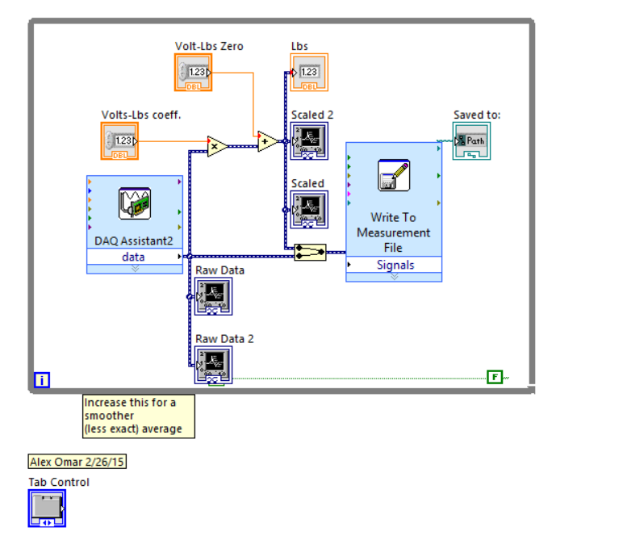

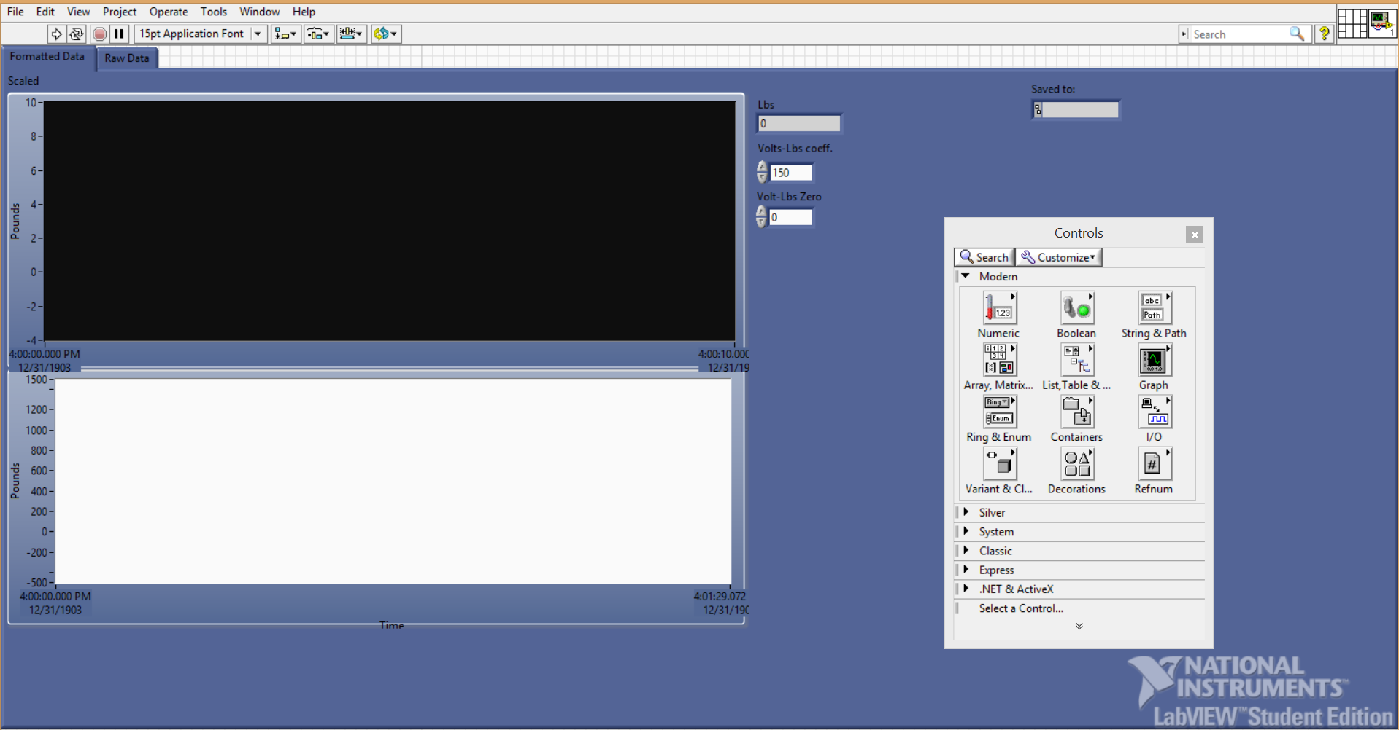 (insert pic when there is a graph)

1. Zero it out by inspection by using the pound-volt zero input
2. Then place known weights on load cell and see if the data is correct
   1. (insert method)
3. If not correct, then adjust the pound-volt coefficient input
4. Repeat steps 4 through 6 until correct readings are outputted by the load cell
5. Disconnect load cell’s cable from relay box, in order to attach load cell in test setup

# Test Setup

## Attach ASM black Test stand to FAR’s I-beam

1. While next to FAR’s medium I-beam, lift the black ASM test stand such that it is 36 inches off the ground or until the top most holes on the I-beam aligns with the top most holes on the test stand, whichever comes first
   1. May use a chair or step stool for placeholder/rest spot
2. Place 16 ½” hex bolts with 16 washers, i.e. one washer on each hex bolt, through the 16 holes onto the test stand and through the I-beam.

Test Stand

Load Cell

Motor

I-beam

1. Place a washer on the other end of the bolts, which would be in between the I beam
2. Then thread the nuts onto the bolts and wrench tighten until ¼ turn past tight.

## Assemble Load Cell to test stand and motor

(Refer to Load Cell-Test Stand-Motor Assembly Procedures)

## Final Touches

1. Fasten Motor to test stand via U-bolts at two locations
   1. Making sure that there is a washer and nut on I beam side and another washer and nut on the test stand side
2. Wrap ratchets around the test stand, motor and I-beam for good measure/extra safety precaution
   1. Two ratchets on either end of the ox tank section

# Cold Flow

## Follow Cold flow procedures

1. (Refer to Nitrous Filling Assembly Procedures)
2. Check load cell data and offset if necessary, using weight of motor as a reference weight
3. Keep SV4 and SV3 closed
4. Open K-bottle
5. Open Hand regulator to max psi
   1. 700 at cool temperatures and 800 at desert temperatures
6. Check Pressure gauge for psi reading when regulator is fully open
7. Open SV3
   1. In the next moment, one should hear hissing. That is from the motor’s vent. This is expected
8. Check for leaks over entire system
   1. First by feeling with gloves. If any force on gloves, check with soapy water next.
9. Close SV3 and Open SV4
   1. This is done to gather proper data
10. Close SV4
11. Start gathering data a few moments before opening solenoid closest to K-bottle (SV3)
12. Open SV3
13. Wait until a white plume appears at vent line
    1. Vent line should be taped to chalkboard for better viewing and for preventing the vent line from whiplashing
14. White plume indicates liquid nitrous has completely filled the Ox-tank
15. Note down weight for wet mass of the motor
16. When tank is full, Follow ignition procedure below

## Ignition

1. Close SV3
2. Stop the run and start a new run
   1. Should automatically save the file when a run is stopped
3. Flip ignition safety switch
   1. Be prepared to duck
4. Flip ignition switch
5. Watch the fireworks

# Post Test

1. After complete combustion and after 1 to 2 minutes, stop the run
2. Wait 10 to 15 minutes for motor to cool down
3. Close K-bottle
4. Open SV3 and SV4
   1. Releases the pressure in tank assembly of filling system
5. Switch of the power on relay box
6. Pack up everything as efficiently and carefully as possible